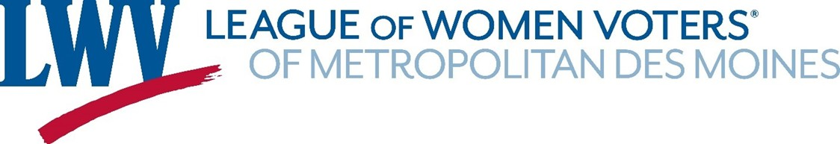

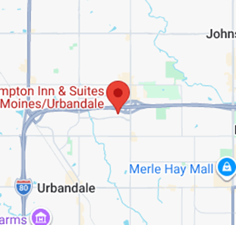
4-16-26 Annual Meeting Agenda
Hampton Inn, 8811 Plum Drive, Urbandale
Food arrangements: Catering by HyVee

5:00 PM - Refreshments and meal
- Call to order, Introductions

- Confirmation of Quorum

- Appointment of: Parliamentarian – Karen Person
Auditors for 2026 Annual meeting minutes
Nominations committee for 2027 annual meeting

- 2025 Annual meeting minutes, motion to approve

- Financial report – Noreen O’Shea, Treasurer

- Remembrance of Past members – Karen Person

- Affirmation of Local Program – Mary Ellen Miller. Co-VP

- President’s report – Teresa Bomhoff, President
- Last Year’s Retrospective – Lettie Prell, Co-VP

- Election of Officers (3) and Director (1)

- Approval of Delegates to State Convention (2),
UMRR (1) and National Convention (3)
6:30 Adjourn Speaker: Peter Benzoni

