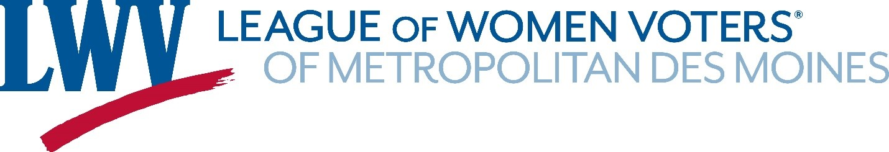
QUALIFIED CHARITABLE DISTRIBUTION FROM YOUR IRA
You have worked hard and planned for retirement. Now, with a little creativity, you can leverage your retirement assets to make a significant, tax-smart gift to the League of Women Voters of Metropolitan Des Moines.
If you are age 70.5 or older, you can request a Qualified Charitable Contribution (QCD) from your retirement account to benefit LWV Metropolitan Des Moines. Here is how it works:
- Request a QCD from your retirement administrator; you may even be able to log in to your online account to make your request.
- The distribution must be sent directly to our mail box - you cannot withdraw the funds first.
- While you will not get a tax deduction for your gift, there is no income tax due on the distribution. This is a great option if you don't itemize.
- If you are 73 or older and need to take a required minimum distribution (RMD), you can direct some or all of it (subject to maximum gifts allowable) as a QCD.
- You can make up to $108,000 in QCD gifts to all charities in a year ($216,000 for married couples who can donate up to $108,000 each from their own retirement plans).
You will need our legal name and tax ID number. And please ask that your administrator include your name on the transfer so we can ensure you get the correct acknowledgment.
League of Women Voters of Metropolitan Des Moines - Tax ID #81-3499277
Kindly have your distribution sent to:
ATTN: Noreen O’Shea,
Treasurer, League of Women Voters of Metropolitan Des Moines
Box 65095
West Des Moines, Iowa 50265
Give for the Future. Naming us as a beneficiary of your retirement plan is a generous way to ensure the future of democracy.

